https://e•æ1ts.whitduse.gov/form/AppointmentGuestList?GuestListCode=N•/2323HTTK

Gregory Lorjuste
Deputy Assistant to the President and Director of Scheduling
Gregory Lorjuste was born the 6th of 9 children to Haitian immigrant parents in Brooklyn,
New York on September 26, 1981. His parents moved to Irvington, New Jersey when he was 12 years old. Gregory attended Mt. Vernon Ave Middle School before entering Irvington High School in 1996. After graduating in 1999, Gregory attended Rider University, where he made quite the name for himself as an active member of Phi Beta Sigma Fraternity, Inc., the Student Government Association, the Black Student Union and becoming Homecoming King his senior year. He graduated from Rider with a degree in Elementary Education and American Studies in 2004.
Gregory attributes much of his success to the Educational Opportunity Program, which he maintains gave him the chance to be more than he ever could dream.
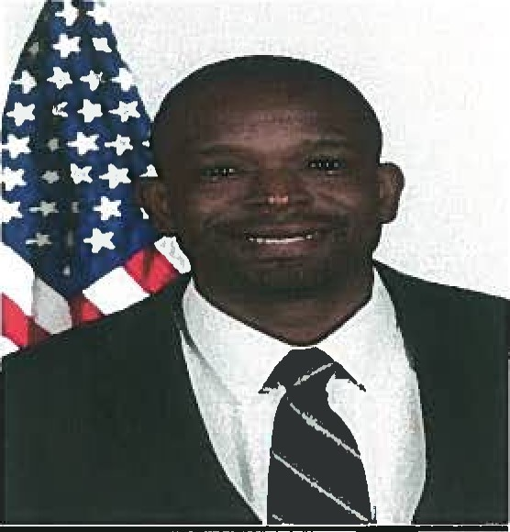
While at Rider, he developed a passion for volunteerism and politics. His first job out of college was a position working for the New Jersey Commission on National and Community Service. Following his stint there, he worked for Former President Bill Clinton at his charitable foundation in Harlem as Assistant Director of Scheduling before taking a position on then-Senator Barack Obama's 2008 Presidential Campaign in Virginia. When asked about his experience, Gregory replied, "It was an honor to be a part of history as the battleground state of Virginia was won by a Democratic candidate for the first time in 44 years."
On the eve of Inauguration Day, Gregory was offered a position to work within the White House, a position he still holds today. As the Deputy Assistant to the President and Director of Scheduling for President Barack Obama, he has been able to travel to 33 different countries with the President. His favorites so far, are the United Kingdom, Ghana, the Czech Republic, South Africa and Cuba.
Since working at the White House, Gregory has been featured twice on BET.com highlighting the work he does and his passion for giving back to the community. He is part of the White House My Brother's Keeper Mentoring program and the White House President's Leadership Workshop group.
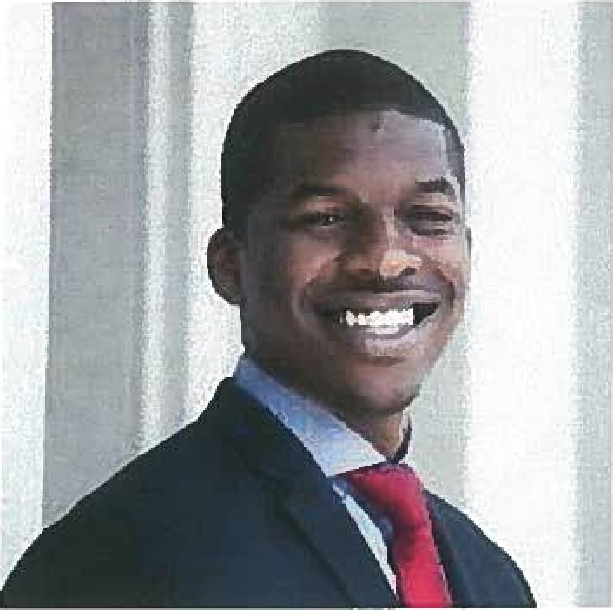

Jeron Smith
Deputy Director of Digital Initiatives
Jeron Smith is the Deputy Director of Digital Initiatives in the White House's Office of Digital Strategy. Prior to the White House, Jeron served in Brand Management roles across several categories and territories at Nike Inc. where he managed the integrated marketing mix to lead disruptive marketing strategy.
Jeron is a native of Southern California; He holds a bachelor's degree in Business Administration from Howard University, and master^{l} s degrees from Georgetown University and Columbia University.
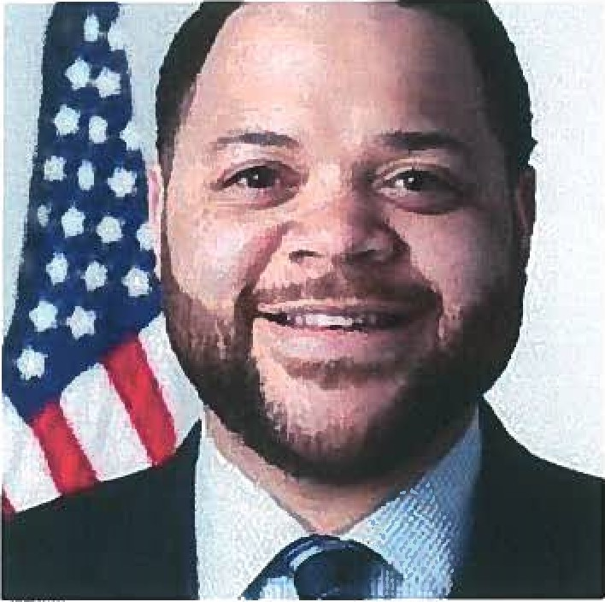
Michael D. Smith
Special Assistant to the President and Senior Director of Cabinet Affairs for My Brother' s Keeper
Michael is Special Assistant to the President and Senior Director of Cabinet Affairs for My Brother's Keeper (MBK) at the White House. In this role he manages the President's initiative to address persistent opportunity gaps faced by boys and young men of color and ensure that all young people can reach their full potential.
Prior to joining the White House team, Michael served as director of the Social Innovation Fund (SIF), a key White House initiative and program of the Corporation for National and Community Service that combines federal and private investment to help scale and replicate evidence-based solutions to complex social challenges.
Before joining the Obama Administration, Michael served as Senior Vice President of Social Innovation at the Case Foundation, where he oversaw the Foundation's giving and program strategy, and guided numerous sector-building initiatives and public-private partnerships, such as the Startup America Partnership. Prior to the Case Foundation, Michael helped build national initiatives aimed at bridging the "digital divide" at the Beaumont Foundation of America and PowerUP, served as a senior program and communications staff member at a the Family Center Boys & Girls Club in Springfield, MA, was an aide to U.S. Congressman Richard E. Neal and received a B.A. in Communications from Marymount University
Maurice Owens is the Head of the Libra Group's Washington D.C office and is responsible for managing the group's policy and government affairs portfolio.
Prior to joining the Libra Group in 2015, Maurice Owens was Special Assistant to the White House Chief of Staff, Denis McDonough. As Special Assistant to the White House Chief of Staff, Maurice served as the primary liaison between the office of Chief of Staff and Capitol Hill. He was also involved with a number of special projects such as the Affordable Care Act Outreach, Immigration Reform Outreach and "My Brother's Keeper" - President Obama's initiative which seeks to help young men of color throughout the USA reach their full potential.
Following a career in the US Air Force as an information and communications technology specialist, Maurice Owens joined the White House Communications Agency in 2007 where he operated and maintained a $45 million secure communications network integrating US agencies and allied nations.

